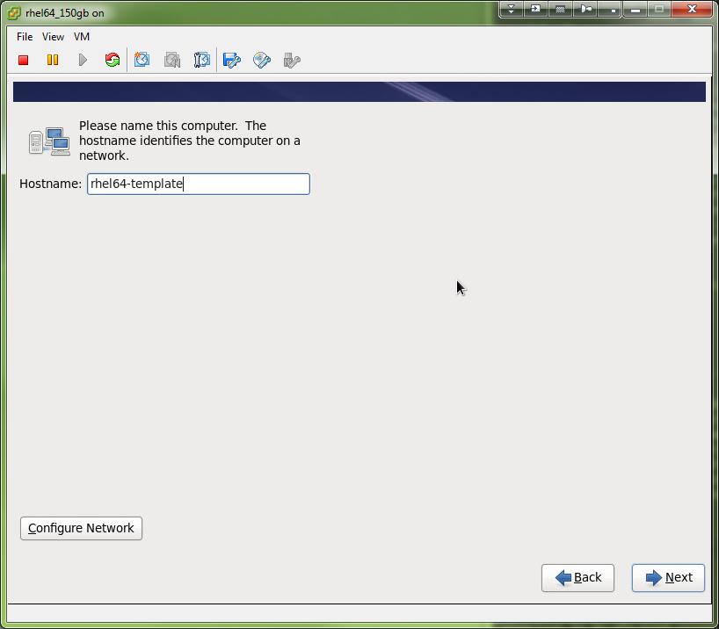

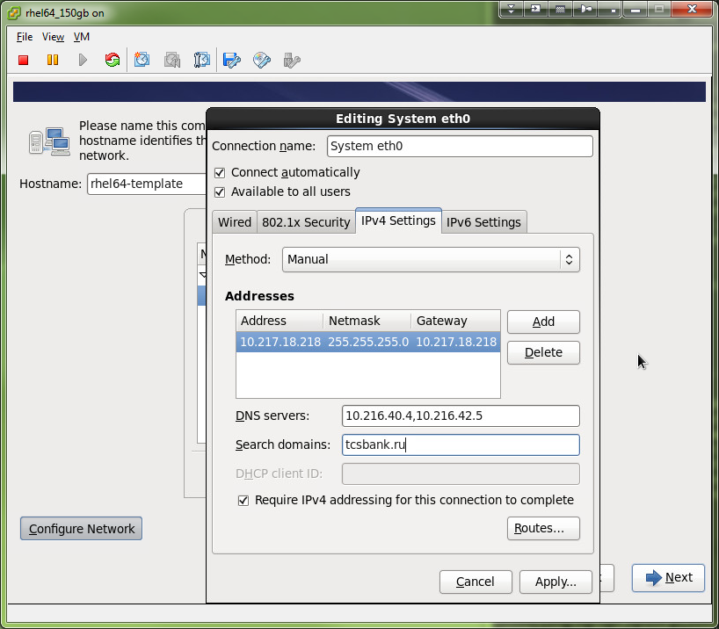

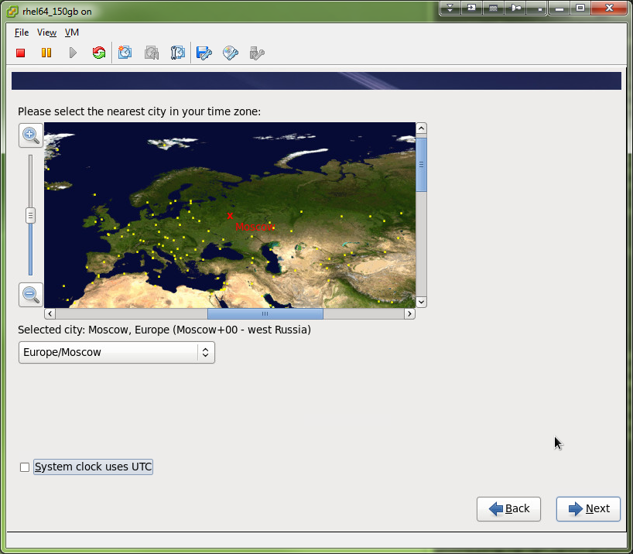

Дефолтовый.
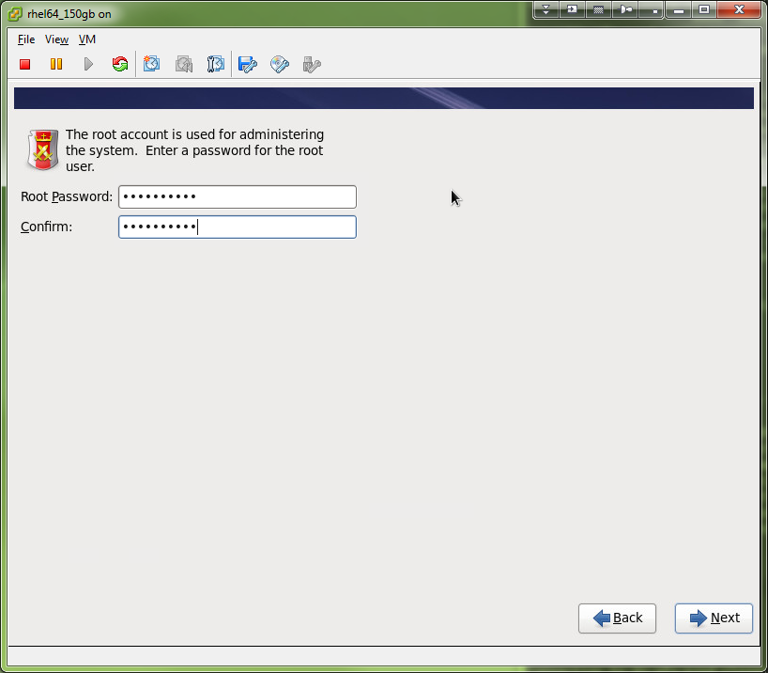

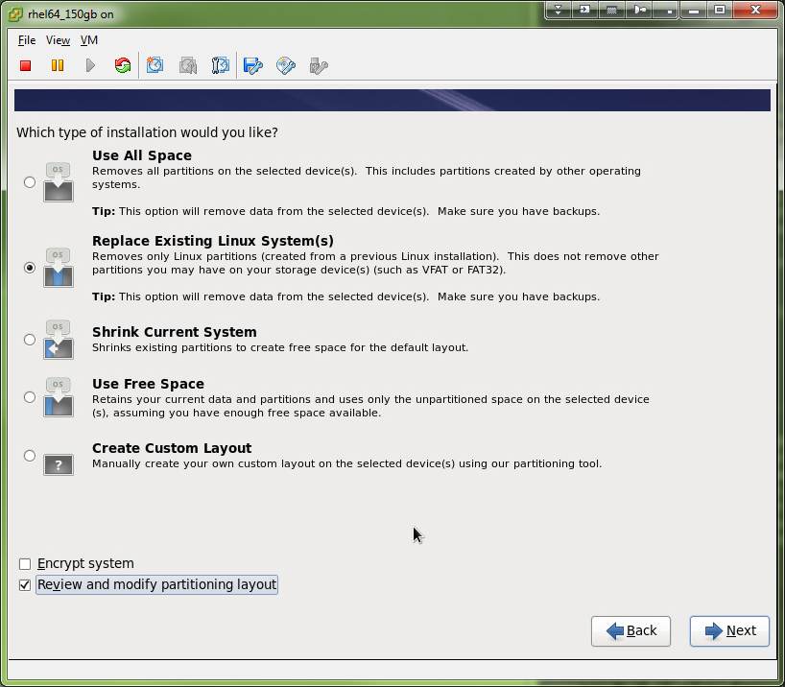

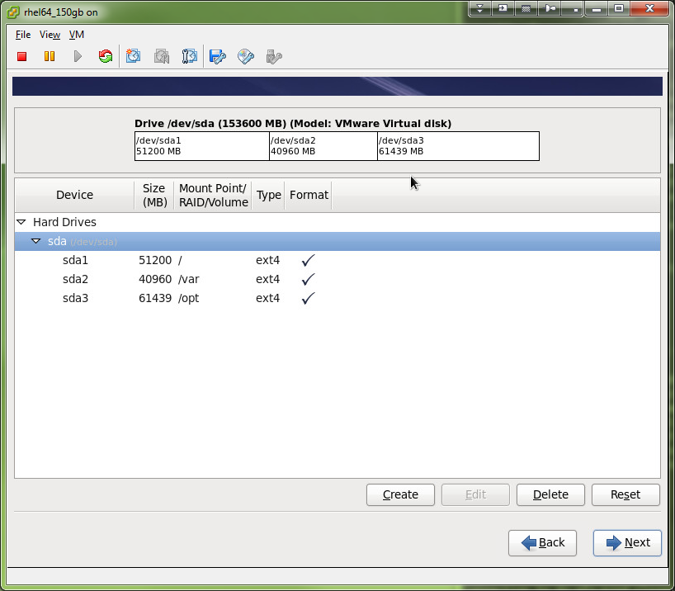

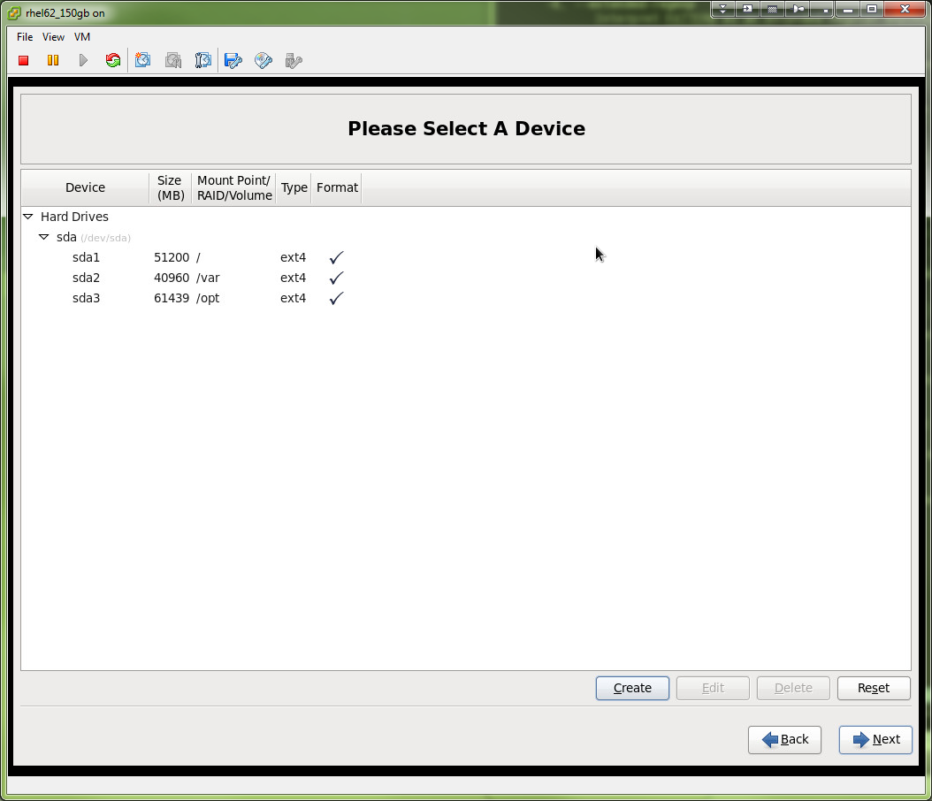

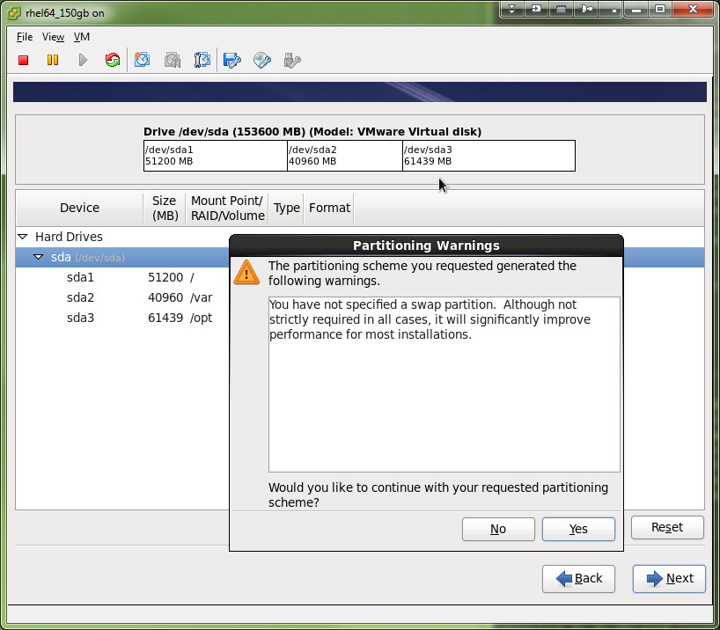

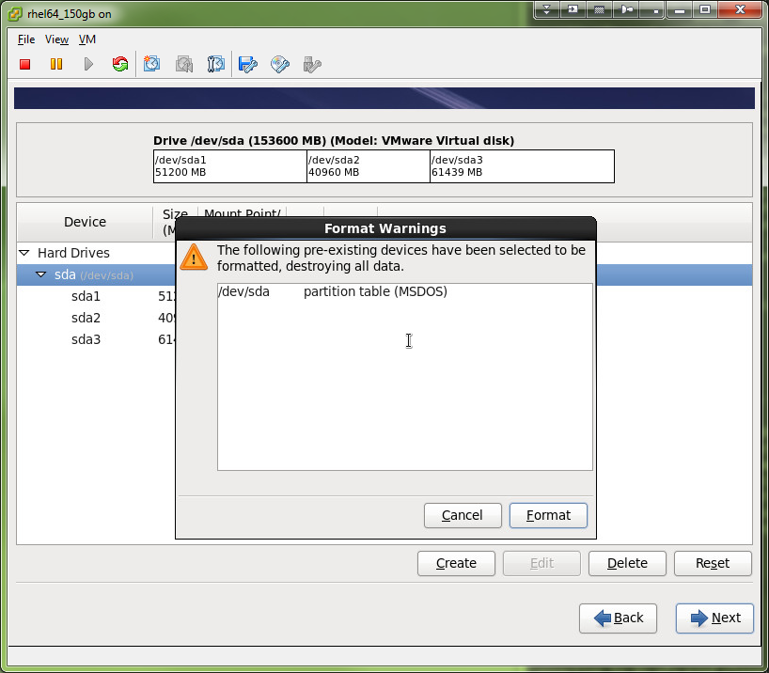

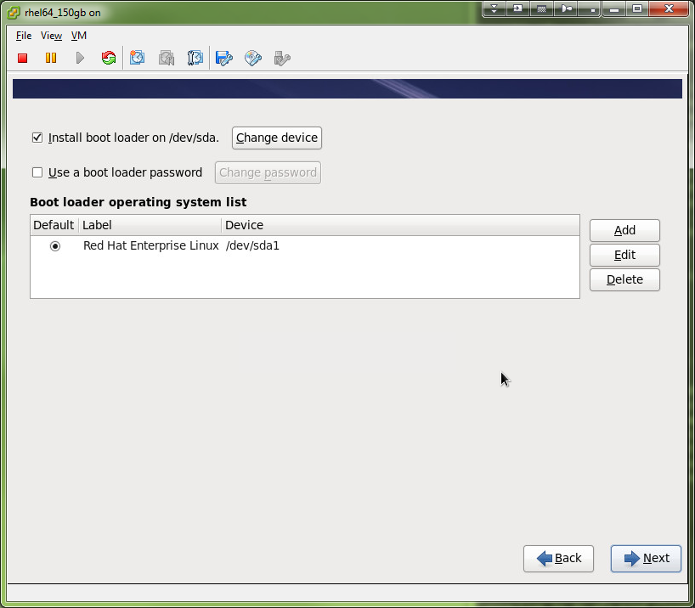

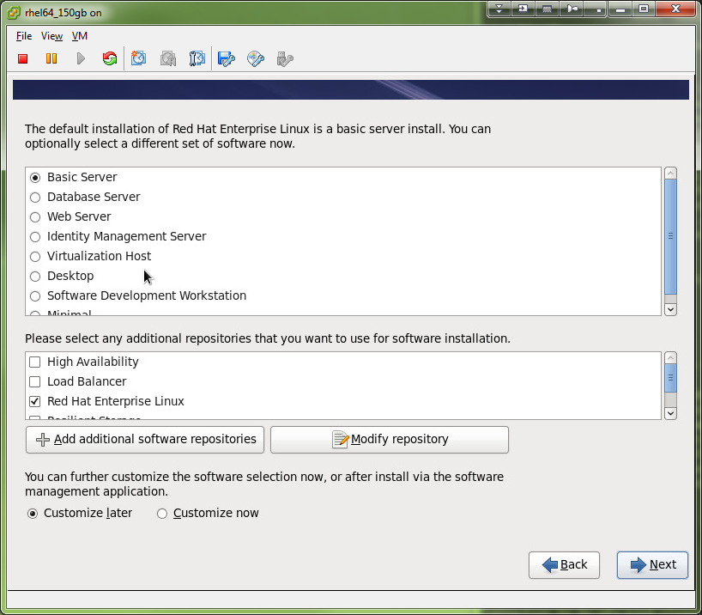

Centos.
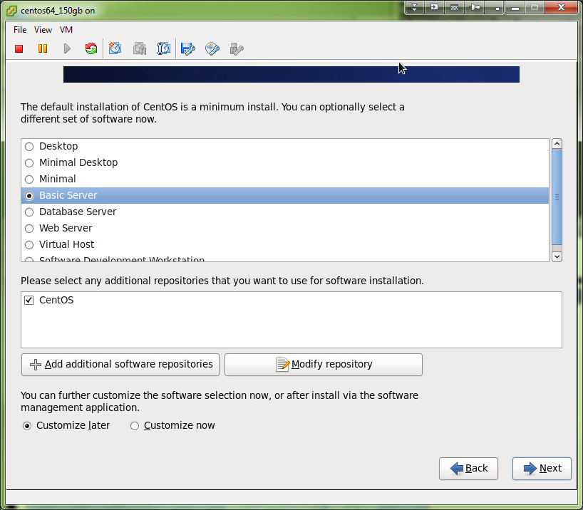

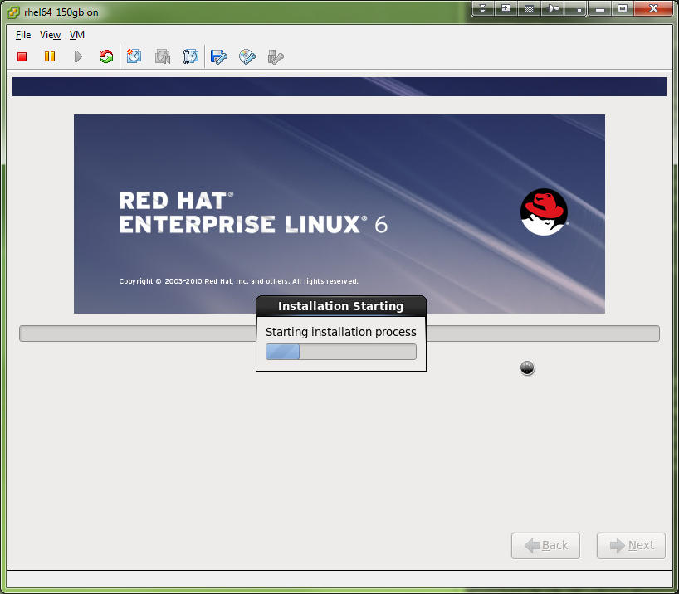

*. Install vmware tools.

[root@centos64-template ~]# mkdir /media/vcdrom
[root@centos64-template ~]#

[root@rhel64-template ~]# mount /dev/cdrom /media/vcdrom
mount: block device /dev/sr0 is write-protected, mounting read-only
[root@rhel64-template ~]# ls /media/vcdrom/
manifest.txt VMwareTools-9.0.5-1283433.tar.gz
[root@rhel64-template ~]#

[root@rhel64-template ~]# cd /tmp
[root@rhel64-template tmp]#

[root@rhel64-template tmp]# tar xvzf /media/vcdrom/VMwareTools-9.0.5-1283433.tar.gz -C /tmp
vmware-tools-distrib/
vmware-tools-distrib/lib/
vmware-tools-distrib/lib/icu/
vmware-tools-distrib/lib/icu/icudt44l.dat
vmware-tools-distrib/lib/modules/
vmware-tools-distrib/lib/modules/binary/
vmware-tools-distrib/lib/modules/binary/bld-2.6.5-7.191-i586bigsmp-SLES9/
...

[root@centos64-template ~]# /tmp/vmware-tools-distrib/vmware-install.pl

[root@rhel64-template vmware-tools-distrib]# ./vmware-install.pl
Creating a new VMware Tools installer database using the tar4 format.

Installing VMware Tools.

In which directory do you want to install the binary files?
[/usr/bin]

What is the directory that contains the init directories (rc0.d/ to rc6.d/)?
[/etc/rc.d]

What is the directory that contains the init scripts?
[/etc/rc.d/init.d]

In which directory do you want to install the daemon files?
[/usr/sbin]

In which directory do you want to install the library files?
[/usr/lib/vmware-tools]

The path "/usr/lib/vmware-tools" does not exist currently. This program is
going to create it, including needed parent directories. Is this what you want?
[yes]

In which directory do you want to install the documentation files?
[/usr/share/doc/vmware-tools]

The path "/usr/share/doc/vmware-tools" does not exist currently. This program
is going to create it, including needed parent directories. Is this what you
want? [yes]

The installation of VMware Tools 9.0.5 build-1283433 for Linux completed
successfully. You can decide to remove this software from your system at any
time by invoking the following command: "/usr/bin/vmware-uninstall-tools.pl".

Before running VMware Tools for the first time, you need to configure it by
invoking the following command: "/usr/bin/vmware-config-tools.pl". Do you want
this program to invoke the command for you now? [yes]

Initializing...

Making sure services for VMware Tools are stopped.

Found a compatible pre-built module for vmci. Installing it...

Found a compatible pre-built module for vsock. Installing it...

The module vmxnet3 has already been installed on this system by another
installer or package and will not be modified by this installer. Use the flag
--clobber-kernel-modules=vmxnet3 to override.

The module pvscsi has already been installed on this system by another
installer or package and will not be modified by this installer. Use the flag
--clobber-kernel-modules=pvscsi to override.

The module vmmemctl has already been installed on this system by another
installer or package and will not be modified by this installer. Use the flag
--clobber-kernel-modules=vmmemctl to override.

The VMware Host-Guest Filesystem allows for shared folders between the host OS
and the guest OS in a Fusion or Workstation virtual environment. Do you wish
to enable this feature? [no]

Found a compatible pre-built module for vmxnet. Installing it...

The vmblock enables dragging or copying files between host and guest in a
Fusion or Workstation virtual environment. Do you wish to enable this feature?
[no]

!!! [EXPERIMENTAL] !!!
VMware automatic kernel modules enables automatic building and installation of
VMware kernel modules at boot that are not already present. By selecting yes,
you will be enabling this experimental feature. You can always disable this
feature by re-running vmware-config-tools.pl.

Would you like to enable VMware automatic kernel modules?
[no]

No X install found.

Creating a new initrd boot image for the kernel.
vmware-tools start/running
The configuration of VMware Tools 9.0.5 build-1283433 for Linux for this
running kernel completed successfully.

You must restart your X session before any mouse or graphics changes take
effect.

You can now run VMware Tools by invoking "/usr/bin/vmware-toolbox-cmd" from the
command line.

To enable advanced X features (e.g., guest resolution fit, drag and drop, and
file and text copy/paste), you will need to do one (or more) of the following:
1. Manually start /usr/bin/vmware-user
2. Log out and log back into your desktop session; and,
3. Restart your X session.

Enjoy,

--the VMware team

Found VMware Tools CDROM mounted at /media/vcdrom. Ejecting device /dev/sr0 ...

[root@rhel64-template vmware-tools-distrib]#

*. Tune swap

http://www.cyberciti.biz/faq/linux-add-a-swap-file-howto/

[root@rhel64-template ~]# dd if=/dev/zero of=/swapfile bs=1024 count=2097152
2097152+0 records in
2097152+0 records out
2147483648 bytes (2.1 GB) copied, 18.6019 s, 115 MB/s
[root@rhel64-template ~]#

[root@rhel64-template ~]# mkswap /swapfile
mkswap: /swapfile: warning: don't erase bootbits sectors
on whole disk. Use -f to force.
Setting up swapspace version 1, size = 2097148 KiB
no label, UUID=135236fd-4202-4b34-8347-b1a0e163abd0
[root@rhel64-template ~]#

[root@rhel64-template ~]# chmod 0600 /swapfile
[root@rhel64-template ~]#

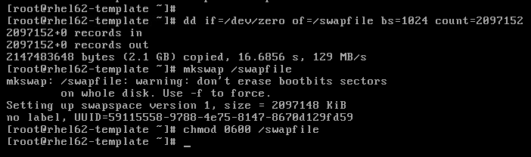

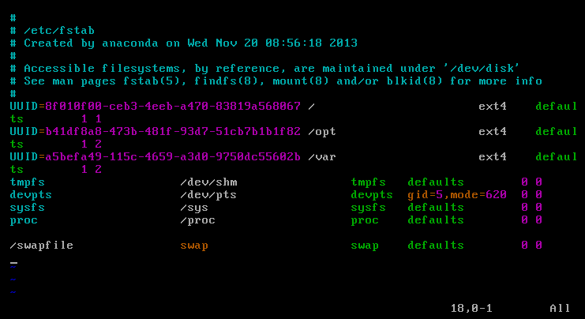

[root@rhel64-template ~]# vim /etc/fstab

/swapfile swap swap defaults 0 0

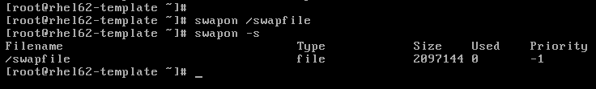

[root@rhel64-template ~]# swapon /swapfile
[root@rhel64-template ~]# swapon -s
Filename Type Size Used Priority
/swapfile file 2097144 0 -1
[root@rhel64-template ~]#

*. Configure to make ipv6 disabled.

Для отключения ipv6 на серверах с операционными системами RedHat, Centos и созданных на их основе нужно выполнить следующие настройки.

Чтобы отключить поддержку ipv6 нужно:

1. Создать файл /etc/modprobe.d/disable-ipv6.conf и вписать в него строчку:
options ipv6 disable=1

Например такой командой:
[root@rhel64-template ~]# echo "options ipv6 disable=1" > /etc/modprobe.d/disable-ipv6.conf
[root@rhel64-template ~]#

2. Вписать в файл /etc/sysconfig/network строчку:
NETWORKING_IPV6=no

3. Модифицировать все конфигурационные файлы etc/sysconfig/network-scripts/ifcfg-ethX сетевых интерфейсов и вписать в них строчки (или заменить значения):
IPV6INIT=no
IPV6_AUTOCONF=no

4. Отключить автоматический запуск firewall iptables для ipv6 после старта сервера. Выполнить команду:
chkconfig ip6tables off

*. Configure network interfaces.

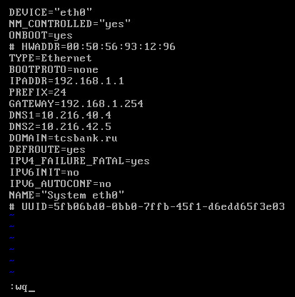

DEVICE=eth0
TYPE=Ethernet
UUID=d499d3cd-72fc-4d19-b7ff-42ed41b96267
ONBOOT=yes
NM_CONTROLLED=yes
BOOTPROTO=none
HWADDR=00:50:56:93:44:D4
IPADDR=10.217.18.219
PREFIX=24
GATEWAY=10.217.18.254
DNS1=10.216.40.4
DNS2=10.216.42.5
DOMAIN=tcsbank.ru
DEFROUTE=yes
IPV4_FAILURE_FATAL=yes
IPV6INIT=no
IPV6_AUTOCONF=no
NAME="System eth0"

[root@rhel64-template ~]# cat /etc/sysconfig/network-scripts/ifcfg-eth0
DEVICE=eth0
TYPE=Ethernet
ONBOOT=yes
NM_CONTROLLED=yes
BOOTPROTO=none
IPADDR=10.217.18.218
NETMASK=255.255.255.0
GATEWAY=10.217.18.254
DEFROUTE=yes
IPV4_FAILURE_FATAL=yes
IPV6INIT=no
IPV6_AUTOCONF=no
[root@rhel64-template ~]#

[root@rhel64-template ~]# cat /etc/sysconfig/network
NETWORKING=yes
HOSTNAME=rhel64-template
GATEWAY=10.217.18.254
NETWORKING_IPV6=no
[root@rhel64-template ~]#

[root@rhel64-template ~]# cat /etc/resolv.conf
# Generated by NetworkManager
search tcsbank.ru
domain tcsbank.ru
nameserver 10.216.40.4
nameserver 10.216.42.5
[root@rhel64-template ~]#

*. Here is disabling iptables

[root@centos64-template ~]# chkconfig iptables off
[root@centos64-template ~]#

*. disabling selinux Enforcing.

[root@rhel64-template ~]# vim /etc/selinux/config

#SELINUX=enforcing
SELINUX=disabled

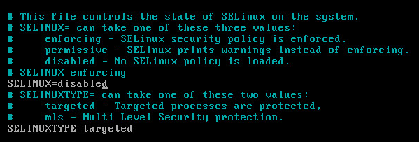

4. Configure repositories.

[root@rhel62-template yum.repos.d]# rhnreg_ks --username=tcsbank17012012 --password=sRsffjdJ --proxy=nag2:3128 --force
[root@rhel62-template yum.repos.d]# rhn_check
[root@rhel62-template yum.repos.d]# yum repolist
Loaded plugins: product-id, rhnplugin, security, subscription-manager
Updating certificate-based repositories.
repo id repo name status
rhel-x86_64-server-6 Red Hat Enterprise Linux Server (v. 6 for 64-bit x86_64) 11,121
repolist: 11,121
[root@rhel62-template yum.repos.d]#
[root@rhel62-template yum.repos.d]# ls
redhat.repo rhel-source.repo
[root@rhel62-template yum.repos.d]#

This link good for RedHat 6.x.
[root@rhel62-template yum.repos.d]# curl -O "http://monitoring2/repo/tcs/yum.repos.d/tcs-epel6.repo"
% Total % Received % Xferd Average Speed Time Time Time Current
Dload Upload Total Spent Left Speed
180 180 180 180 0 0 5699 0 --:--:-- --:--:-- --:--:-- 90000

This link good for Centos.
This repositorium “epel” need to be installed for installing nagios plugins.
[root@centos64-template yum.repos.d]# rpm -ivh --httpproxy nag2.tcsbank.ru --httpport 3128 http://dl.fedoraproject.org/pub/epel/6/x86_64/epel-release-6-8.noarch.rpm
Retrieving http://dl.fedoraproject.org/pub/epel/6/x86_64/epel-release-6-8.noarch.rpm
warning: /var/tmp/rpm-tmp.xytbbt: Header V3 RSA/SHA256 Signature, key ID 0608b895: NOKEY
Preparing... ########################################### [100%]
1:epel-release ########################################### [100%]
[root@centos64-template yum.repos.d]#

It does not work properly.
[root@centos64-template yum.repos.d]# curl -O "http://monitoring2/repo/tcs/yum.repos.d/tcs-epel.repo"
% Total % Received % Xferd Average Speed Time Time Time Current
Dload Upload Total Spent Left Speed
190 190 190 190 0 0 10920 0 --:--:-- --:--:-- --:--:-- 95000
[root@centos64-template yum.repos.d]#

[root@rhel62-template yum.repos.d]# curl -O "http://monitoring2/repo/tcs/yum.repos.d/tcs-hp.repo"
% Total % Received % Xferd Average Speed Time Time Time Current
Dload Upload Total Spent Left Speed
185 185 185 185 0 0 26737 0 --:--:-- --:--:-- --:--:-- 180k

This link good for RedHat 6.2.
[root@rhel62-template yum.repos.d]# curl -O "http://monitoring2/repo/tcs/yum.repos.d/tcs-rhel62.repo"
% Total % Received % Xferd Average Speed Time Time Time Current
Dload Upload Total Spent Left Speed
110 440 110 440 0 0 62331 0 --:--:-- --:--:-- --:--:-- 214k

This link good for RedHat 6.4.
[root@rhel64-template yum.repos.d]# curl -O "http://monitoring2/repo/tcs/yum.repos.d/tcs-rhel64.repo"
% Total % Received % Xferd Average Speed Time Time Time Current
Dload Upload Total Spent Left Speed
127 254 127 254 0 0 31698 0 --:--:-- --:--:-- --:--:-- 248k
[root@rhel64-template yum.repos.d]#

This link good for Centos.
[root@centos64-template yum.repos.d]# curl -O "http://monitoring2/repo/tcs/yum.repos.d/tcs-centos.repo"
% Total % Received % Xferd Average Speed Time Time Time Current
Dload Upload Total Spent Left Speed
104 209 104 209 0 0 32697 0 --:--:-- --:--:-- --:--:-- 102k
[root@centos64-template yum.repos.d]#

Install RepoForge repository for RedHat 6.x or CentOS 6.x.
[root@ds-mon11t yum.repos.d]# rpm -ivh --httpproxy nag2.tcsbank.ru --httpport 3128 http://pkgs.repoforge.org/rpmforge-release/rpmforge-release-0.5.3-1.el6.rf.x86_64.rpm
Retrieving http://pkgs.repoforge.org/rpmforge-release/rpmforge-release-0.5.3-1.el6.rf.x86_64.rpm
Preparing... ########################################### [100%]
package rpmforge-release-0.5.3-1.el6.rf.x86_64 is already installed
[root@ds-mon11t yum.repos.d]#

http://repoforge.org/use/
Hints:
Use cat /etc/redhat-release to find which release of EL you are using
Use uname -a to find your processor architecture
Use rpm -ivh package-filename to install the rpmforge-release package (also works with URLs)
You can use wget or curl to download the package using one of the above links if needed (for example on a server with no X Window)
Then you can use yum to install the available packages from the RepoForge repo, e.g. yum install --enablerepo=rpmforge-extras
Afterward, you can disable accidental updates from the repo by setting enabled = 0 in the repo definition file in /etc/yum.repos.d/

[root@rhel62-template yum.repos.d]# curl -O "http://monitoring2/repo/tcs/yum.repos.d/tcs-remi.repo"
% Total % Received % Xferd Average Speed Time Time Time Current
Dload Upload Total Spent Left Speed
107 644 107 644 0 0 101k 0 --:--:-- --:--:-- --:--:-- 314k
[root@rhel62-template yum.repos.d]#
[root@rhel62-template yum.repos.d]# curl -O "http://monitoring2/repo/tcs/yum.repos.d/tcs-puppetlabs.repo"
% Total % Received % Xferd Average Speed Time Time Time Current
Dload Upload Total Spent Left Speed
119 479 119 479 0 0 82472 0 --:--:-- --:--:-- --:--:-- 467k
[root@rhel62-template yum.repos.d]#

[root@rhel62-template yum.repos.d]# yum repolist
Loaded plugins: product-id, rhnplugin, security, subscription-manager
Updating certificate-based repositories.
puppetlabs | 1.9 kB 00:00
puppetlabs/primary_db | 99 kB 00:00
puppetlabs-dependencies | 1.9 kB 00:00
puppetlabs-dependencies/primary_db | 21 kB 00:00
repo id repo name status
EPEL TCS EPEL repository 10,015
puppetlabs Puppet Labs Packages 304
puppetlabs-dependencies Puppet Labs Packages Dependencies 54
rhel-hp Red Hat Enterprise Linux HP repository 6Server - x86_64 - Source 35
rhel-x86_64-server-6 Red Hat Enterprise Linux Server (v. 6 for 64-bit x86_64) 11,121
rhel62 Red Hat Enterprise Linux 6Server - x86_64 - Source 3,529
rhel62-update Red Hat Enterprise Linux 6Server - x86_64 - Update 131
repolist: 25,189
[root@rhel62-template yum.repos.d]#

*. Install puppet agent.

[root@rhel62-template yum.repos.d]# yum install ruby
Loaded plugins: product-id, rhnplugin, security, subscription-manager
Updating certificate-based repositories.
Setting up Install Process
Resolving Dependencies
--> Running transaction check
---> Package ruby.x86_64 0:1.8.7.352-12.el6_4 will be installed
--> Processing Dependency: ruby-libs = 1.8.7.352-12.el6_4 for package: ruby-1.8.7.352-12.el6_4.x86_64
--> Processing Dependency: libruby.so.1.8()(64bit) for package: ruby-1.8.7.352-12.el6_4.x86_64
--> Running transaction check
---> Package ruby-libs.x86_64 0:1.8.7.352-12.el6_4 will be installed
--> Processing Dependency: libreadline.so.5()(64bit) for package: ruby-libs-1.8.7.352-12.el6_4.x86_64
--> Running transaction check
---> Package compat-readline5.x86_64 0:5.2-17.1.el6 will be installed
--> Finished Dependency Resolution

Dependencies Resolved

======================================================================================================================================================================
Package Arch Version Repository Size
======================================================================================================================================================================
Installing:
ruby x86_64 1.8.7.352-12.el6_4 rhel-x86_64-server-6 534 k
Installing for dependencies:
compat-readline5 x86_64 5.2-17.1.el6 rhel-x86_64-server-6 129 k
ruby-libs x86_64 1.8.7.352-12.el6_4 rhel-x86_64-server-6 1.6 M

Transaction Summary
======================================================================================================================================================================
Install 3 Package(s)

Total download size: 2.3 M
Installed size: 0
Is this ok [y/N]: y
Downloading Packages:
(1/3): compat-readline5-5.2-17.1.el6.x86_64.rpm | 129 kB 00:00
(2/3): ruby-1.8.7.352-12.el6_4.x86_64.rpm | 534 kB 00:00
(3/3): ruby-libs-1.8.7.352-12.el6_4.x86_64.rpm | 1.6 MB 00:01
----------------------------------------------------------------------------------------------------------------------------------------------------------------------
Total 392 kB/s | 2.3 MB 00:05
warning: rpmts_HdrFromFdno: Header V3 RSA/SHA256 Signature, key ID fd431d51: NOKEY
Retrieving key from file:///etc/pki/rpm-gpg/RPM-GPG-KEY-redhat-release
Importing GPG key 0xFD431D51:
Userid : Red Hat, Inc. (release key 2) <security@redhat.com>
Package: redhat-release-server-6Server-6.2.0.3.el6.x86_64 (@anaconda-RedHatEnterpriseLinux-201111171049.x86_64/6.2)
From : /etc/pki/rpm-gpg/RPM-GPG-KEY-redhat-release
Is this ok [y/N]: y
Importing GPG key 0x2FA658E0:
Userid : Red Hat, Inc. (auxiliary key) <security@redhat.com>
Package: redhat-release-server-6Server-6.2.0.3.el6.x86_64 (@anaconda-RedHatEnterpriseLinux-201111171049.x86_64/6.2)
From : /etc/pki/rpm-gpg/RPM-GPG-KEY-redhat-release
Is this ok [y/N]: y
Running rpm_check_debug
Running Transaction Test
Transaction Test Succeeded
Running Transaction
Installing : compat-readline5-5.2-17.1.el6.x86_64 1/3
Installing : ruby-libs-1.8.7.352-12.el6_4.x86_64 2/3
Installing : ruby-1.8.7.352-12.el6_4.x86_64 3/3
rhel62/productid | 1.7 kB 00:00
Installed products updated.

Installed:
ruby.x86_64 0:1.8.7.352-12.el6_4

Dependency Installed:
compat-readline5.x86_64 0:5.2-17.1.el6 ruby-libs.x86_64 0:1.8.7.352-12.el6_4

Complete!
[root@rhel62-template yum.repos.d]#

[root@rhel62-template yum.repos.d]# yum --showduplicates puppet
Loaded plugins: product-id, rhnplugin, security, subscription-manager
Updating certificate-based repositories.
No such command: puppet. Please use /usr/bin/yum --help
[root@rhel62-template yum.repos.d]# yum --showduplicates list puppet
Loaded plugins: product-id, rhnplugin, security, subscription-manager
Updating certificate-based repositories.
Available Packages
puppet.noarch 2.6.9-2.el6 puppetlabs
puppet.noarch 2.6.10-1.el6 puppetlabs
puppet.noarch 2.6.11-1.el6 puppetlabs
puppet.noarch 2.6.12-1.el6 puppetlabs
puppet.noarch 2.6.12-2.el6 puppetlabs
puppet.noarch 2.6.14-1.el6 puppetlabs
puppet.noarch 2.6.15-1.el6 puppetlabs
puppet.noarch 2.6.16-1.el6 puppetlabs
puppet.noarch 2.6.17-1.el6 puppetlabs
puppet.noarch 2.6.18-1.el6 puppetlabs
puppet.noarch 2.6.18-3.el6 EPEL
puppet.noarch 2.7.1-1.el6 puppetlabs
puppet.noarch 2.7.3-1.el6 puppetlabs
puppet.noarch 2.7.4-1.el6 puppetlabs
puppet.noarch 2.7.5-1.el6 puppetlabs
puppet.noarch 2.7.6-1.el6 puppetlabs
puppet.noarch 2.7.6-2.el6 puppetlabs
puppet.noarch 2.7.8-1.el6 puppetlabs
puppet.noarch 2.7.9-1.el6 puppetlabs
puppet.noarch 2.7.9-2.el6 puppetlabs
puppet.noarch 2.7.10-1.el6 puppetlabs
puppet.noarch 2.7.11-1.el6 puppetlabs
puppet.noarch 2.7.11-2.el6 puppetlabs
puppet.noarch 2.7.12-1.el6 puppetlabs
puppet.noarch 2.7.13-1.el6 puppetlabs
puppet.noarch 2.7.14-1.el6 puppetlabs
puppet.noarch 2.7.14-2.el6 puppetlabs
puppet.noarch 2.7.14-3.el6 puppetlabs
puppet.noarch 2.7.16-1.el6 puppetlabs
puppet.noarch 2.7.17-1.el6 puppetlabs
puppet.noarch 2.7.18-1.el6 puppetlabs
puppet.noarch 2.7.19-1.el6 puppetlabs
puppet.noarch 2.7.20-1.el6 puppetlabs
puppet.noarch 2.7.21-1.el6 puppetlabs
puppet.noarch 2.7.22-1.el6 puppetlabs
puppet.noarch 2.7.23-1.el6 puppetlabs
puppet.noarch 3.0.0-1.el6 puppetlabs
puppet.noarch 3.0.1-1.el6 puppetlabs
puppet.noarch 3.0.2-1.el6 puppetlabs
puppet.noarch 3.1.0-1.el6 puppetlabs
puppet.noarch 3.1.1-1.el6 puppetlabs
puppet.noarch 3.2.1-1.el6 puppetlabs
puppet.noarch 3.2.2-1.el6 puppetlabs
puppet.noarch 3.2.3-1.el6 puppetlabs
puppet.noarch 3.2.4-1.el6 puppetlabs
puppet.noarch 3.3.0-1.el6 puppetlabs
puppet.noarch 3.3.1-1.el6 puppetlabs
puppet.noarch 3.3.2-1.el6 puppetlabs
[root@rhel62-template yum.repos.d]#

[root@rhel62-template yum.repos.d]# yum install puppet-3.2.4-1.el6
Loaded plugins: product-id, rhnplugin, security, subscription-manager
Updating certificate-based repositories.
Setting up Install Process
Resolving Dependencies
--> Running transaction check
---> Package puppet.noarch 0:3.2.4-1.el6 will be installed
--> Processing Dependency: facter >= 1.6.11 for package: puppet-3.2.4-1.el6.noarch
--> Processing Dependency: ruby-rgen >= 0.6.5 for package: puppet-3.2.4-1.el6.noarch
--> Processing Dependency: hiera >= 1.0.0 for package: puppet-3.2.4-1.el6.noarch
--> Processing Dependency: ruby-augeas for package: puppet-3.2.4-1.el6.noarch
--> Processing Dependency: ruby-shadow for package: puppet-3.2.4-1.el6.noarch
--> Processing Dependency: ruby(selinux) for package: puppet-3.2.4-1.el6.noarch
--> Running transaction check
---> Package facter.x86_64 1:1.7.3-1.el6 will be installed
---> Package hiera.noarch 0:1.2.1-1.el6 will be installed
--> Processing Dependency: rubygem-json for package: hiera-1.2.1-1.el6.noarch
---> Package libselinux-ruby.x86_64 0:2.0.94-5.3.el6_4.1 will be installed
--> Processing Dependency: libselinux = 2.0.94-5.3.el6_4.1 for package: libselinux-ruby-2.0.94-5.3.el6_4.1.x86_64
---> Package ruby-augeas.x86_64 0:0.4.1-1.el6 will be installed
--> Processing Dependency: augeas-libs >= 0.8.0 for package: ruby-augeas-0.4.1-1.el6.x86_64
--> Processing Dependency: libaugeas.so.0(AUGEAS_0.8.0)(64bit) for package: ruby-augeas-0.4.1-1.el6.x86_64
--> Processing Dependency: libaugeas.so.0(AUGEAS_0.12.0)(64bit) for package: ruby-augeas-0.4.1-1.el6.x86_64
--> Processing Dependency: libaugeas.so.0(AUGEAS_0.11.0)(64bit) for package: ruby-augeas-0.4.1-1.el6.x86_64
--> Processing Dependency: libaugeas.so.0(AUGEAS_0.10.0)(64bit) for package: ruby-augeas-0.4.1-1.el6.x86_64
--> Processing Dependency: libaugeas.so.0(AUGEAS_0.1.0)(64bit) for package: ruby-augeas-0.4.1-1.el6.x86_64
--> Processing Dependency: libaugeas.so.0()(64bit) for package: ruby-augeas-0.4.1-1.el6.x86_64
---> Package ruby-rgen.noarch 0:0.6.5-1.el6 will be installed
---> Package ruby-shadow.x86_64 0:1.4.1-13.el6 will be installed
--> Running transaction check
---> Package augeas-libs.x86_64 0:0.9.0-4.el6 will be installed
---> Package libselinux.x86_64 0:2.0.94-5.2.el6 will be updated
--> Processing Dependency: libselinux = 2.0.94-5.2.el6 for package: libselinux-utils-2.0.94-5.2.el6.x86_64
---> Package libselinux.x86_64 0:2.0.94-5.3.el6_4.1 will be an update
---> Package rubygem-json.x86_64 0:1.7.3-2.el6_3 will be installed
--> Processing Dependency: ruby(rubygems) for package: rubygem-json-1.7.3-2.el6_3.x86_64
--> Running transaction check
---> Package libselinux-utils.x86_64 0:2.0.94-5.2.el6 will be updated
---> Package libselinux-utils.x86_64 0:2.0.94-5.3.el6_4.1 will be an update
---> Package rubygems.noarch 0:1.8.16-1.el6 will be installed
--> Processing Dependency: ruby-rdoc for package: rubygems-1.8.16-1.el6.noarch
--> Running transaction check
---> Package ruby-rdoc.x86_64 0:1.8.7.352-12.el6_4 will be installed
--> Processing Dependency: ruby-irb = 1.8.7.352-12.el6_4 for package: ruby-rdoc-1.8.7.352-12.el6_4.x86_64
--> Running transaction check
---> Package ruby-irb.x86_64 0:1.8.7.352-12.el6_4 will be installed
--> Finished Dependency Resolution

Dependencies Resolved

======================================================================================================================================================================
Package Arch Version Repository Size
======================================================================================================================================================================
Installing:
puppet noarch 3.2.4-1.el6 puppetlabs 1.0 M
Installing for dependencies:
augeas-libs x86_64 0.9.0-4.el6 rhel-x86_64-server-6 317 k
facter x86_64 1:1.7.3-1.el6 puppetlabs 85 k
hiera noarch 1.2.1-1.el6 puppetlabs 21 k
libselinux-ruby x86_64 2.0.94-5.3.el6_4.1 rhel-x86_64-server-6 99 k
ruby-augeas x86_64 0.4.1-1.el6 EPEL 21 k
ruby-irb x86_64 1.8.7.352-12.el6_4 rhel-x86_64-server-6 313 k
ruby-rdoc x86_64 1.8.7.352-12.el6_4 rhel-x86_64-server-6 376 k
ruby-rgen noarch 0.6.5-1.el6 puppetlabs-dependencies 87 k
ruby-shadow x86_64 1.4.1-13.el6 EPEL 11 k
rubygem-json x86_64 1.7.3-2.el6_3 rhel62-update 61 k
rubygems noarch 1.8.16-1.el6 rhel62-update 170 k
Updating for dependencies:
libselinux x86_64 2.0.94-5.3.el6_4.1 rhel-x86_64-server-6 108 k
libselinux-utils x86_64 2.0.94-5.3.el6_4.1 rhel-x86_64-server-6 81 k

Transaction Summary
======================================================================================================================================================================
Install 12 Package(s)
Upgrade 2 Package(s)

Total download size: 2.7 M
Is this ok [y/N]: y
Downloading Packages:
(1/14): augeas-libs-0.9.0-4.el6.x86_64.rpm | 317 kB 00:00
(2/14): facter-1.7.3-1.el6.x86_64.rpm | 85 kB 00:00
(3/14): hiera-1.2.1-1.el6.noarch.rpm | 21 kB 00:00
(4/14): libselinux-2.0.94-5.3.el6_4.1.x86_64.rpm | 108 kB 00:00
(5/14): libselinux-ruby-2.0.94-5.3.el6_4.1.x86_64.rpm | 99 kB 00:00
(6/14): libselinux-utils-2.0.94-5.3.el6_4.1.x86_64.rpm | 81 kB 00:00
(7/14): puppet-3.2.4-1.el6.noarch.rpm | 1.0 MB 00:01
(8/14): ruby-augeas-0.4.1-1.el6.x86_64.rpm | 21 kB 00:00
(9/14): ruby-irb-1.8.7.352-12.el6_4.x86_64.rpm | 313 kB 00:01
(10/14): ruby-rdoc-1.8.7.352-12.el6_4.x86_64.rpm | 376 kB 00:00
(11/14): ruby-rgen-0.6.5-1.el6.noarch.rpm | 87 kB 00:00
(12/14): ruby-shadow-1.4.1-13.el6.x86_64.rpm | 11 kB 00:00
(13/14): rubygem-json-1.7.3-2.el6_3.x86_64.rpm | 61 kB 00:00
(14/14): rubygems-1.8.16-1.el6.noarch.rpm | 170 kB 00:00
----------------------------------------------------------------------------------------------------------------------------------------------------------------------
Total 185 kB/s | 2.7 MB 00:15
warning: rpmts_HdrFromFdno: Header V3 RSA/SHA256 Signature, key ID 0608b895: NOKEY
Retrieving key from http://monitoring2.tcsbank.ru/repo/epel/RPM-GPG-KEY-EPEL-6
Importing GPG key 0x0608B895:
Userid: "EPEL (6) <epel@fedoraproject.org>"
From : http://monitoring2.tcsbank.ru/repo/epel/RPM-GPG-KEY-EPEL-6
Is this ok [y/N]: y
warning: rpmts_HdrFromFdno: Header V4 RSA/SHA1 Signature, key ID 4bd6ec30: NOKEY
Retrieving key from http://monitoring2.tcsbank.ru/repo/puppetlabs/RPM-GPG-KEY-puppetlabs
Importing GPG key 0x4BD6EC30:
Userid: "Puppet Labs Release Key (Puppet Labs Release Key) <info@puppetlabs.com>"
From : http://monitoring2.tcsbank.ru/repo/puppetlabs/RPM-GPG-KEY-puppetlabs
Is this ok [y/N]: y
Running rpm_check_debug
Running Transaction Test
Transaction Test Succeeded
Running Transaction
Updating : libselinux-2.0.94-5.3.el6_4.1.x86_64 1/16
Installing : augeas-libs-0.9.0-4.el6.x86_64 2/16
Installing : ruby-augeas-0.4.1-1.el6.x86_64 3/16
Installing : libselinux-ruby-2.0.94-5.3.el6_4.1.x86_64 4/16
Updating : libselinux-utils-2.0.94-5.3.el6_4.1.x86_64 5/16
Installing : ruby-shadow-1.4.1-13.el6.x86_64 6/16
Installing : ruby-rgen-0.6.5-1.el6.noarch 7/16
Installing : ruby-irb-1.8.7.352-12.el6_4.x86_64 8/16
Installing : ruby-rdoc-1.8.7.352-12.el6_4.x86_64 9/16
Installing : rubygems-1.8.16-1.el6.noarch 10/16
Installing : rubygem-json-1.7.3-2.el6_3.x86_64 11/16
Installing : hiera-1.2.1-1.el6.noarch 12/16
Installing : 1:facter-1.7.3-1.el6.x86_64 13/16
Installing : puppet-3.2.4-1.el6.noarch 14/16
Cleanup : libselinux-utils-2.0.94-5.2.el6.x86_64 15/16
Cleanup : libselinux-2.0.94-5.2.el6.x86_64 16/16
Installed products updated.

Installed:
puppet.noarch 0:3.2.4-1.el6

Dependency Installed:
augeas-libs.x86_64 0:0.9.0-4.el6 facter.x86_64 1:1.7.3-1.el6 hiera.noarch 0:1.2.1-1.el6 libselinux-ruby.x86_64 0:2.0.94-5.3.el6_4.1
ruby-augeas.x86_64 0:0.4.1-1.el6 ruby-irb.x86_64 0:1.8.7.352-12.el6_4 ruby-rdoc.x86_64 0:1.8.7.352-12.el6_4 ruby-rgen.noarch 0:0.6.5-1.el6
ruby-shadow.x86_64 0:1.4.1-13.el6 rubygem-json.x86_64 0:1.7.3-2.el6_3 rubygems.noarch 0:1.8.16-1.el6

Dependency Updated:
libselinux.x86_64 0:2.0.94-5.3.el6_4.1 libselinux-utils.x86_64 0:2.0.94-5.3.el6_4.1

Complete!
[root@rhel62-template yum.repos.d]#

*. Configure for nagios usage.

[root@rhel62-template yum.repos.d]# yum install nagios-plugins nagios-plugins-disk nagios-plugins-load nagios-plugins-nrpe nagios-plugins-procs nagios-plugins-users nagios-plugins-load nagios-plugins-swap nrpe
Loaded plugins: product-id, rhnplugin, security, subscription-manager
Updating certificate-based repositories.
Setting up Install Process
Resolving Dependencies
--> Running transaction check
---> Package nagios-plugins.x86_64 0:1.4.16-10.el6 will be installed
--> Processing Dependency: nagios-common >= 3.3.1-1 for package: nagios-plugins-1.4.16-10.el6.x86_64
---> Package nagios-plugins-disk.x86_64 0:1.4.16-10.el6 will be installed
---> Package nagios-plugins-load.x86_64 0:1.4.16-10.el6 will be installed
---> Package nagios-plugins-nrpe.x86_64 0:2.14-5.el6 will be installed
---> Package nagios-plugins-procs.x86_64 0:1.4.16-10.el6 will be installed
---> Package nagios-plugins-swap.x86_64 0:1.4.16-10.el6 will be installed
---> Package nagios-plugins-users.x86_64 0:1.4.16-10.el6 will be installed
---> Package nrpe.x86_64 0:2.14-5.el6 will be installed
--> Running transaction check
---> Package nagios-common.x86_64 0:3.5.1-1.el6 will be installed
--> Finished Dependency Resolution

Dependencies Resolved

======================================================================================================================================================================
Package Arch Version Repository Size
======================================================================================================================================================================
Installing:
nagios-plugins x86_64 1.4.16-10.el6 EPEL 200 k
nagios-plugins-disk x86_64 1.4.16-10.el6 EPEL 69 k
nagios-plugins-load x86_64 1.4.16-10.el6 EPEL 31 k
nagios-plugins-nrpe x86_64 2.14-5.el6 EPEL 23 k
nagios-plugins-procs x86_64 1.4.16-10.el6 EPEL 67 k
nagios-plugins-swap x86_64 1.4.16-10.el6 EPEL 32 k
nagios-plugins-users x86_64 1.4.16-10.el6 EPEL 29 k
nrpe x86_64 2.14-5.el6 EPEL 223 k
Installing for dependencies:
nagios-common x86_64 3.5.1-1.el6 EPEL 17 k

Transaction Summary
======================================================================================================================================================================
Install 9 Package(s)

Total download size: 691 k
Installed size: 1.6 M
Is this ok [y/N]: y
Downloading Packages:
(1/9): nagios-common-3.5.1-1.el6.x86_64.rpm | 17 kB 00:00
(2/9): nagios-plugins-1.4.16-10.el6.x86_64.rpm | 200 kB 00:00
(3/9): nagios-plugins-disk-1.4.16-10.el6.x86_64.rpm | 69 kB 00:00
(4/9): nagios-plugins-load-1.4.16-10.el6.x86_64.rpm | 31 kB 00:00
(5/9): nagios-plugins-nrpe-2.14-5.el6.x86_64.rpm | 23 kB 00:00
(6/9): nagios-plugins-procs-1.4.16-10.el6.x86_64.rpm | 67 kB 00:00
(7/9): nagios-plugins-swap-1.4.16-10.el6.x86_64.rpm | 32 kB 00:00
(8/9): nagios-plugins-users-1.4.16-10.el6.x86_64.rpm | 29 kB 00:00
(9/9): nrpe-2.14-5.el6.x86_64.rpm | 223 kB 00:00
----------------------------------------------------------------------------------------------------------------------------------------------------------------------
Total 2.4 MB/s | 691 kB 00:00
Running rpm_check_debug
Running Transaction Test
Transaction Test Succeeded
Running Transaction
Installing : nagios-common-3.5.1-1.el6.x86_64 1/9
Installing : nagios-plugins-1.4.16-10.el6.x86_64 2/9
Installing : nagios-plugins-procs-1.4.16-10.el6.x86_64 3/9
Installing : nagios-plugins-swap-1.4.16-10.el6.x86_64 4/9
Installing : nagios-plugins-disk-1.4.16-10.el6.x86_64 5/9
Installing : nagios-plugins-users-1.4.16-10.el6.x86_64 6/9
Installing : nagios-plugins-load-1.4.16-10.el6.x86_64 7/9
Installing : nagios-plugins-nrpe-2.14-5.el6.x86_64 8/9
Installing : nrpe-2.14-5.el6.x86_64 9/9
Installed products updated.

Installed:
nagios-plugins.x86_64 0:1.4.16-10.el6 nagios-plugins-disk.x86_64 0:1.4.16-10.el6 nagios-plugins-load.x86_64 0:1.4.16-10.el6
nagios-plugins-nrpe.x86_64 0:2.14-5.el6 nagios-plugins-procs.x86_64 0:1.4.16-10.el6 nagios-plugins-swap.x86_64 0:1.4.16-10.el6
nagios-plugins-users.x86_64 0:1.4.16-10.el6 nrpe.x86_64 0:2.14-5.el6

Dependency Installed:
nagios-common.x86_64 0:3.5.1-1.el6

Complete!
[root@rhel62-template yum.repos.d]#

[root@rhel62-template yum.repos.d]# vim /etc/nagios/nrpe.cfg
...
allowed_hosts=127.0.0.1,nag2.tcsbank.ru,monitoring1.tcsbank.ru,monitoring2.tcsbank.ru,monitoring3.tcsbank.ru,monitoring4.tcsbank.ru,monitoring5.tcsbank.ru,monitoring6.tcsbank.ru

[support@centos00 nrpe.d]$ scp check_* root@10.217.18.217:/etc/nrpe.d/
or
[s.belogrud.tcs4500] ➤ scp /drives/d/share/nagios/nrpe.d/check_* root@10.217.18.225:/etc/nrpe.d/

[support@centos00 plugins]$ scp check_* root@10.217.18.217:/usr/lib64/nagios/plugins/

[root@rhel62-template nrpe.d]# vim check_disks.cfg

command[check_boot_fs]=/usr/lib64/nagios/plugins/check_disk -W 20% -K 10% -w 20% -c 10% -p /boot
command[check_root_fs]=/usr/lib64/nagios/plugins/check_disk -W 20% -K 10% -u MB -w 100 -c 50 -p /
command[check_home_fs]=/usr/lib64/nagios/plugins/check_disk -W 20% -K 10% -u MB -w 100 -c 50 -p /home
command[check_var_fs]=/usr/lib64/nagios/plugins/check_disk -W 20% -K 10% -u MB -w 100 -c 50 -p /var
command[check_tmp_fs]=/usr/lib64/nagios/plugins/check_disk -W 20% -K 10% -u MB -w 100 -c 50 -p /tmp
command[check_opt_fs]=/usr/lib64/nagios/plugins/check_disk -W 20% -K 10% -u MB -w 100 -c 50 -p /opt

[root@rhel62-template nrpe.d]# chkconfig nrpe on
[root@rhel62-template nrpe.d]#

*. Configure snmp

[root@rhel62-template nrpe.d]# yum install net-snmp net-snmp-utils
Loaded plugins: product-id, rhnplugin, security, subscription-manager
Updating certificate-based repositories.
Setting up Install Process
Resolving Dependencies
--> Running transaction check
---> Package net-snmp.x86_64 1:5.5-44.el6_4.4 will be installed
--> Processing Dependency: net-snmp-libs = 1:5.5-44.el6_4.4 for package: 1:net-snmp-5.5-44.el6_4.4.x86_64
--> Processing Dependency: libsensors.so.4()(64bit) for package: 1:net-snmp-5.5-44.el6_4.4.x86_64
--> Processing Dependency: libnetsnmptrapd.so.20()(64bit) for package: 1:net-snmp-5.5-44.el6_4.4.x86_64
--> Processing Dependency: libnetsnmpmibs.so.20()(64bit) for package: 1:net-snmp-5.5-44.el6_4.4.x86_64
--> Processing Dependency: libnetsnmphelpers.so.20()(64bit) for package: 1:net-snmp-5.5-44.el6_4.4.x86_64
--> Processing Dependency: libnetsnmpagent.so.20()(64bit) for package: 1:net-snmp-5.5-44.el6_4.4.x86_64
--> Processing Dependency: libnetsnmp.so.20()(64bit) for package: 1:net-snmp-5.5-44.el6_4.4.x86_64
---> Package net-snmp-utils.x86_64 1:5.5-44.el6_4.4 will be installed
--> Running transaction check
---> Package lm_sensors-libs.x86_64 0:3.1.1-17.el6 will be installed
---> Package net-snmp-libs.x86_64 1:5.5-44.el6_4.4 will be installed
--> Finished Dependency Resolution

Dependencies Resolved

======================================================================================================================================================================
Package Arch Version Repository Size
======================================================================================================================================================================
Installing:
net-snmp x86_64 1:5.5-44.el6_4.4 rhel-x86_64-server-6 303 k
net-snmp-utils x86_64 1:5.5-44.el6_4.4 rhel-x86_64-server-6 172 k
Installing for dependencies:
lm_sensors-libs x86_64 3.1.1-17.el6 rhel-x86_64-server-6 38 k
net-snmp-libs x86_64 1:5.5-44.el6_4.4 rhel-x86_64-server-6 1.5 M

Transaction Summary
======================================================================================================================================================================
Install 4 Package(s)

Total download size: 2.0 M
Installed size: 0
Is this ok [y/N]: y
Downloading Packages:
(1/4): lm_sensors-libs-3.1.1-17.el6.x86_64.rpm | 38 kB 00:00
(2/4): net-snmp-5.5-44.el6_4.4.x86_64.rpm | 303 kB 00:00
(3/4): net-snmp-libs-5.5-44.el6_4.4.x86_64.rpm | 1.5 MB 00:01
(4/4): net-snmp-utils-5.5-44.el6_4.4.x86_64.rpm | 172 kB 00:00
----------------------------------------------------------------------------------------------------------------------------------------------------------------------
Total 295 kB/s | 2.0 MB 00:07
Running rpm_check_debug
Running Transaction Test
Transaction Test Succeeded
Running Transaction
Installing : lm_sensors-libs-3.1.1-17.el6.x86_64 1/4
Installing : 1:net-snmp-libs-5.5-44.el6_4.4.x86_64 2/4
Installing : 1:net-snmp-utils-5.5-44.el6_4.4.x86_64 3/4
Installing : 1:net-snmp-5.5-44.el6_4.4.x86_64 4/4
Installed products updated.

Installed:
net-snmp.x86_64 1:5.5-44.el6_4.4 net-snmp-utils.x86_64 1:5.5-44.el6_4.4

Dependency Installed:
lm_sensors-libs.x86_64 0:3.1.1-17.el6 net-snmp-libs.x86_64 1:5.5-44.el6_4.4

Complete!
[root@rhel62-template nrpe.d]#

[root@rhel62-template nrpe.d]# vim /etc/snmp/snmpd.conf

###############################################################################
# Access Control
###############################################################################
rocommunity tcspub 127.0.0.1
rocommunity tcspub 172.16.1.11
rocommunity tcspub 172.16.1.14
rocommunity tcspub 172.16.1.19
trapcommunity tcspub
trapsink 172.16.1.11 tcspub

[root@rhel62-template nrpe.d]# chkconfig snmpd on
[root@rhel62-template nrpe.d]#

*. Configure ntp.

[root@rhel62-template nrpe.d]# vim /etc/ntp.conf

# Use public servers from the pool.ntp.org project.
# Please consider joining the pool (http://www.pool.ntp.org/join.html).
#server 0.rhel.pool.ntp.org
#server 1.rhel.pool.ntp.org
#server 2.rhel.pool.ntp.org
server ntp01.tcsbank.ru iburst
server ntp02.tcsbank.ru iburst
server ntp03.tcsbank.ru iburst

[root@rhel62-template nrpe.d]# chkconfig ntpd on
[root@rhel62-template nrpe.d]#

[root@centos64-template yum.repos.d]# ntpdate ntp01.tcsbank.ru
21 Nov 12:53:57 ntpdate[8741]: adjust time server 10.219.12.7 offset -0.061006 sec
[root@centos64-template yum.repos.d]#
[root@centos64-template yum.repos.d]# service ntpd start
Starting ntpd: [ OK ]
[root@centos64-template yum.repos.d]# ntpq -pn
remote refid st t when poll reach delay offset jitter
==============================================================================
10.219.12.7 194.190.168.1 2 u 2 64 1 2.678 -47.759 2.457
*172.20.16.193 194.190.168.1 2 u 1 64 1 1.470 -51.265 2.016
172.20.16.194 172.25.0.1 3 u 2 64 1 1.376 -56.136 1.419
[root@centos64-template yum.repos.d]#

*. Configure timezone.

[root@rhel62-template nrpe.d]# vim /etc/sysconfig/clock

ZONE="Europe/Moscow"
UTC=false

*. Configure users and wheel access.

[root@rhel62-template nrpe.d]# visudo

## Allows people in group wheel to run all commands
%wheel ALL=(ALL) ALL

Useradd all linux administrator accounts.

[root@rhel64-template plugins]# useradd -u 501 -c 'Aleksey Tertentyev,BC Diapazone,2037' -d /home/tan -m -G root,wheel -s /bin/bash -p '$1$vjkXeATR$Yp20XAZWMNX7q9E5pYth1.' tan
[root@rhel64-template plugins]# useradd -u 503 -c 'Aleksey Aleksandrov,BC Diapazone,2138' -d /home/avk -m -G root,wheel -s /bin/bash -p '$1$rWT5HuLB$B2rz1lJd6PTzr/zAsUVE9.' avk
[root@rhel64-template plugins]# useradd -u 504 -c 'Nikita Makhnev,BC Diapazone,2069' -d /home/lzn -m -G root,wheel -s /bin/bash -p '$1$acxcWmj6$ipbLi0qgPU607lMEvmTxm1' lzn
[root@rhel64-template plugins]# useradd -u 525 -c "Belogrud Sergey Vladimirovich,BC Diapazone,2173" -d /home/bsv -m -G root,wheel -s /bin/bash -p '$6$aTOUz./e$V/Svdh3ZepbOGq7wVwMbscFoV2CB7jz5C.l/upLpyD7WmxPwjMJg8cyI4V7sZwKcN7ODLAcmZNHHerELq.bPh0' bsv
[root@rhel64-template plugins]# useradd -u 528 -c 'Chernyh Aleksandr,BC Diapazone,2287' -d '/home/che' -m -G root,wheel -s /bin/bash -p '$6$b2mekjgP$8LikVu/Wz.2bPx7shCuvUHM0dGs/.CvyATOBzR43nYgvKpeJws2tSGL43qM1eOXavNO.SBxP5nHeE/5uMMyGZ.' che
[root@rhel64-template plugins]# useradd -u 529 -c 'Zbiranik Evgeniy,BC Diapazone,2502' -d '/home/zbir' -m -G root,wheel -s /bin/bash -p '$1$1UXDz1eM$fxh64nIOL6KZ6371PItv9/' zbir
[root@rhel64-template plugins]#

*. Installing Zabbix agent.

[root@rhel62-template ~]# cd /etc/pki/rpm-gpg/

[root@rhel62-template rpm-gpg]# rpm --import --httpproxy nag2:3128 http://repo.zabbix.com/RPM-GPG-KEY-ZABBIX
[root@rhel62-template rpm-gpg]#

[root@rhel62-template rpm-gpg]# rpm --import --httpproxy nag2.tcsbank.ru --httpport 3128 http://repo.zabbix.com/RPM-GPG-KEY-ZABBIX
[root@rhel62-template rpm-gpg]# ls
RPM-GPG-KEY-redhat-beta RPM-GPG-KEY-redhat-legacy-former RPM-GPG-KEY-redhat-legacy-release RPM-GPG-KEY-redhat-legacy-rhx RPM-GPG-KEY-redhat-release
[root@rhel62-template rpm-gpg]#

[root@rhel62-template rpm-gpg]# rpm --import --httpproxy nag2.tcsbank.ru --httpport 3128 http://repo.zabbixzone.com/centos/RPM-GPG-KEY-zabbixzone
[root@rhel62-template rpm-gpg]# ls
RPM-GPG-KEY-redhat-beta RPM-GPG-KEY-redhat-legacy-former RPM-GPG-KEY-redhat-legacy-release RPM-GPG-KEY-redhat-legacy-rhx RPM-GPG-KEY-redhat-release
[root@rhel62-template rpm-gpg]#

https://www.zabbix.com/documentation/ru/2.0/manual/installation/install_from_packages

[root@rhel62-template rpm-gpg]# rpm -ivh --httpproxy nag2.tcsbank.ru --httpport 3128 http://repo.zabbix.com/zabbix/2.0/rhel/6/x86_64/zabbix-release-2.0-1.el6.noarch.rpm
Retrieving http://repo.zabbix.com/zabbix/2.0/rhel/6/x86_64/zabbix-release-2.0-1.el6.noarch.rpm
Preparing... ########################################### [100%]
1:zabbix-release ########################################### [100%]
[root@rhel62-template rpm-gpg]#

[root@rhel62-template rpm-gpg]# ls /etc/pki/rpm-gpg
RPM-GPG-KEY-redhat-beta RPM-GPG-KEY-redhat-legacy-release RPM-GPG-KEY-redhat-release
RPM-GPG-KEY-redhat-legacy-former RPM-GPG-KEY-redhat-legacy-rhx RPM-GPG-KEY-ZABBIX
[root@rhel62-template rpm-gpg]#

[root@rhel62-template rpm-gpg]# vim /etc/yum.conf
...
proxy=http://nag2.tcsbank.ru:3128

[root@rhel62-template rpm-gpg]# yum repolist
Loaded plugins: product-id, rhnplugin, security, subscription-manager
Updating certificate-based repositories.
EPEL | 4.2 kB 00:00
puppetlabs | 1.9 kB 00:00
puppetlabs-dependencies | 1.9 kB 00:00
rhel-hp | 951 B 00:00
rhel62 | 4.0 kB 00:00
rhel62-update | 951 B 00:00
zabbix | 951 B 00:00
zabbix/primary | 32 kB 00:00
zabbix 209/209
zabbix-non-supported | 951 B 00:00
zabbix-non-supported/primary | 3.1 kB 00:00
zabbix-non-supported 14/14
repo id repo name status
EPEL TCS EPEL repository 10,015
puppetlabs Puppet Labs Packages 304
puppetlabs-dependencies Puppet Labs Packages Dependencies 54
rhel-hp Red Hat Enterprise Linux HP repository 6Server - x86_64 - Source 35
rhel-x86_64-server-6 Red Hat Enterprise Linux Server (v. 6 for 64-bit x86_64) 11,121
rhel62 Red Hat Enterprise Linux 6Server - x86_64 - Source 3,529
rhel62-update Red Hat Enterprise Linux 6Server - x86_64 - Update 131
zabbix Zabbix Official Repository - x86_64 209
zabbix-non-supported Zabbix Official Repository non-supported - x86_64 14
repolist: 25,412
[root@rhel62-template rpm-gpg]#

[root@rhel62-template rpm-gpg]# yum --showduplicates list zabbix
Loaded plugins: product-id, rhnplugin, security, subscription-manager
Updating certificate-based repositories.
Available Packages
zabbix.x86_64 1.8.18-1.el6 EPEL
zabbix.x86_64 2.0.0-1.el6 zabbix
zabbix.x86_64 2.0.1-1.el6 zabbix
zabbix.x86_64 2.0.1-2.el6 zabbix
zabbix.x86_64 2.0.2-1.el6 zabbix
zabbix.x86_64 2.0.3-1.el6 zabbix
zabbix.x86_64 2.0.4-1.el6 zabbix
zabbix.x86_64 2.0.5-1.el6 zabbix
zabbix.x86_64 2.0.6-1.el6 zabbix
zabbix.x86_64 2.0.7-1.el6 zabbix
zabbix.x86_64 2.0.8-1.el6 zabbix
zabbix.x86_64 2.0.8-2.el6 zabbix
zabbix.x86_64 2.0.8-3.el6 zabbix
zabbix.x86_64 2.0.9-1.el6 zabbix
[root@rhel62-template rpm-gpg]#

[root@rhel62-template rpm-gpg]# yum install zabbix-agent
Loaded plugins: product-id, rhnplugin, security, subscription-manager
Updating certificate-based repositories.
Setting up Install Process
Resolving Dependencies
--> Running transaction check
---> Package zabbix-agent.x86_64 0:2.0.9-1.el6 will be installed
--> Processing Dependency: zabbix = 2.0.9-1.el6 for package: zabbix-agent-2.0.9-1.el6.x86_64
--> Running transaction check
---> Package zabbix.x86_64 0:2.0.9-1.el6 will be installed
--> Finished Dependency Resolution

Dependencies Resolved

======================================================================================================================================================================
Package Arch Version Repository Size
======================================================================================================================================================================
Installing:
zabbix-agent x86_64 2.0.9-1.el6 zabbix 138 k
Installing for dependencies:
zabbix x86_64 2.0.9-1.el6 zabbix 122 k

Transaction Summary
======================================================================================================================================================================
Install 2 Package(s)

Total download size: 260 k
Installed size: 872 k
Is this ok [y/N]: y
Downloading Packages:
(1/2): zabbix-2.0.9-1.el6.x86_64.rpm | 122 kB 00:00
(2/2): zabbix-agent-2.0.9-1.el6.x86_64.rpm | 138 kB 00:00
----------------------------------------------------------------------------------------------------------------------------------------------------------------------
Total 313 kB/s | 260 kB 00:00
Running rpm_check_debug
Running Transaction Test
Transaction Test Succeeded
Running Transaction
Warning: RPMDB altered outside of yum.
Installing : zabbix-2.0.9-1.el6.x86_64 1/2
Installing : zabbix-agent-2.0.9-1.el6.x86_64 2/2
Installed products updated.

Installed:
zabbix-agent.x86_64 0:2.0.9-1.el6

Dependency Installed:
zabbix.x86_64 0:2.0.9-1.el6

Complete!
[root@rhel62-template rpm-gpg]#

[root@rhel62-template rpm-gpg]# vim /etc/zabbix/zabbix_agentd.conf

#Server=127.0.0.1
Server=127.0.0.1,monitoring1.tcsbank.ru,monitoring2.tcsbank.ru,monitoring3.tcsbank.ru,monitoring4.tcsbank.ru,monitoring5.tcsbank.ru,monitoring6.tcsbank.ru

[root@rhel62-template rpm-gpg]# chkconfig zabbix-agent on
[root@rhel62-template rpm-gpg]#

[root@rhel62-template rpm-gpg]# service zabbix-agent start
[root@rhel62-template rpm-gpg]#

[root@rhel62-template rpm-gpg]# less /var/log/zabbix/zabbix_agentd.log
2001:20131120:165125.316 Starting Zabbix Agent [Zabbix server]. Zabbix 2.0.9 (revision 39085).
2009:20131120:165125.321 agent #3 started [listener]
2010:20131120:165125.322 agent #4 started [active checks]
2008:20131120:165125.322 agent #2 started [listener]
2010:20131120:165125.322 active check configuration update from [127.0.0.1:10051] started to fail (cannot connect to [[127.0.0.1]:10051]: [111] Connection refused)
2007:20131120:165125.323 agent #1 started [listener]
2006:20131120:165125.323 agent #0 started [collector]
[root@rhel62-template rpm-gpg]#

20131225

*. Good idea to add time stamp to history file

I had have added string “export HISTTIMEFORMAT='%F %T '” to file /root/.bash_profile then make relogin and get timestamp!
[root@centos00 ~]# cat /root/.bash_profile
# .bash_profile

# Get the aliases and functions
if [ -f ~/.bashrc ]; then
. ~/.bashrc
fi

# User specific environment and startup programs

PATH=$PATH:$HOME/bin

export PATH
export HISTTIMEFORMAT='%F %T '

[root@centos00 ~]#

[root@centos00 ~]# history | tail
408 2013-12-25 12:02:35 man filesystems
409 2013-12-25 12:02:35 find /usr/share/man | grep -i filesy
410 2013-12-25 12:02:35 find /usr/share/man | grep -i tree
411 2013-12-25 12:02:35 man hier
412 2013-12-25 12:02:35 cd ~
413 2013-12-25 12:02:35 ls -Alh
414 2013-12-25 12:02:35 vim .bash_profile
415 2013-12-25 12:02:35 exit
416 2013-12-25 12:02:41 ls
417 2013-12-25 12:02:50 history | tail
[root@centos00 ~]#

20140417
I think good idea is add this line to skeleton file.

[root@redhat01 ~]# vim /etc/skel/.bash_profile
# Get the aliases and functions
if [ -f ~/.bashrc ]; then
. ~/.bashrc
fi

# User specific environment and startup programs

PATH=$PATH:$HOME/bin

export PATH
export HISTTIMEFORMAT='%F %T '

*. Increase number UID and GID for new created users.

Set numbers from 500 to 10000

vim /etc/login.defs
...
UID_MIN 10000
…
GID_MIN 10000
...

*. Configure auditd

[root@redhat01 audit]# vim auditd.conf
#
# This file controls the configuration of the audit daemon
#

log_file = /var/log/audit/audit.log
log_format = RAW
log_group = root
#priority_boost = 4
priority_boost = 10
flush = INCREMENTAL
freq = 20
#num_logs = 5
num_logs = 10
disp_qos = lossy
dispatcher = /sbin/audispd
name_format = NONE
##name = mydomain
#max_log_file = 6
max_log_file = 100
max_log_file_action = ROTATE
space_left = 75
space_left_action = SYSLOG
action_mail_acct = root
admin_space_left = 50
admin_space_left_action = SUSPEND
disk_full_action = SUSPEND
disk_error_action = SUSPEND
##tcp_listen_port =
tcp_listen_queue = 5
tcp_max_per_addr = 1
##tcp_client_ports = 1024-65535
tcp_client_max_idle = 0
enable_krb5 = no
krb5_principal = auditd
##krb5_key_file = /etc/audit/audit.key
[root@redhat01 audit]#

[root@redhat01 audit]# vim audit.rules
## This file contains the auditctl rules that are loaded
## whenever the audit daemon is started via the initscripts.
## The rules are simply the parameters that would be passed
## to auditctl.
##
## First rule - delete all
-D

## Increase the buffers to survive stress events.
## Make this bigger for busy systems
-b 8192

# Audit all changes in /etc/ and other directories.
-w /etc/ -p wa -k access_etc
-w /var/spool/cron/ -p wa -k access_cron
-w /var/spool/at/ -p wa -k access_at
# Too much messages from follow line. Wherefore it was commented.
#-w /var/log/ -p w -k access_log

# This line just for example. It could be used in future.
##- Use of privileged commands (unsuccessful and successful)
## use find /bin -type f -perm -04000 2>/dev/null and put all those files in a rule like this
-a always,exit -F path=/bin/su -F perm=x -F auid>=500 -F auid!=4294967295 -k privileged_software
-a always,exit -F path=/bin/mount -F perm=x -F auid>=500 -F auid!=4294967295 -k privileged_software
-a always,exit -F path=/bin/umount -F perm=x -F auid>=500 -F auid!=4294967295 -k privileged_software
-a always,exit -F path=/bin/ping -F perm=x -F auid>=500 -F auid!=4294967295 -k privileged_software

-a always,exit -F path=/usr/bin/sudo -F perm=x -F auid>=500 -F auid!=4294967295 -k privileged_software

[root@redhat01 audit]#

[root@redhat01 audit]# service auditd restart
Stopping auditd: [ OK ]
Starting auditd: [ OK ]
[root@redhat01 audit]#

*. After all configured (before transform vm to template).
Remove one row from file.

After execution of that command we will lost communication with host.
[root@rhel64-template vmware-tools-distrib]# service network stop
Shutting down interface eth0:
...

[root@rhel62-template ~]# vim /etc/udev/rules.d/70-persistent-net.rules

# This file was automatically generated by the /lib/udev/write_net_rules
# program, run by the persistent-net-generator.rules rules file.
#
# You can modify it, as long as you keep each rule on a single
# line, and change only the value of the NAME= key.

# PCI device 0x15ad:0x07b0 (vmxnet3)
SUBSYSTEM=="net", ACTION=="add", DRIVERS=="?*", ATTR{address}=="00:50:56:93:12:96", ATTR{type}=="1", KERNEL=="eth*", NAME="eth0"

[root@rhel64-template ~]# yum repolist
Loaded plugins: product-id, rhnplugin, security, subscription-manager
This system is not registered to Red Hat Subscription Management. You can use subscription-manager to register.
This system is receiving updates from RHN Classic or RHN Satellite.
EPEL | 4.2 kB 00:00
EPEL/primary_db | 5.7 MB 00:00
puppetlabs | 1.9 kB 00:00
puppetlabs/primary_db | 99 kB 00:00
puppetlabs-dependencies | 1.9 kB 00:00
http://monitoring2.tcsbank.ru/repo/puppetlabs/el/6Server/dependencies/x86_64/repodata/primary.sqlite.bz2: [Errno 12] Timeout on http://monitoring2.tcsbank.ru/repo/puppetlabs/el/6Server/dependencies/x86_64/repodata/primary.sqlite.bz2: (28, 'Operation too slow. Less than 1 bytes/sec transfered the last 30 seconds')
Trying other mirror.
puppetlabs-dependencies/primary_db | 21 kB 00:00
rhel-hp | 951 B 00:00
rhel-hp/primary | 19 kB 00:00
rhel-hp 35/35
rhel62 | 4.0 kB 00:00
rhel62/primary_db | 3.1 MB 00:00
rhel62-update | 951 B 00:00
rhel62-update/primary | 228 kB 00:00
rhel62-update 131/131
repo id repo name status
EPEL TCS EPEL repository 10,015
puppetlabs Puppet Labs Packages 304
puppetlabs-dependencies Puppet Labs Packages Dependencies 54
rhel-hp Red Hat Enterprise Linux HP repository 6Server - x86_64 - Source 35
rhel-x86_64-server-6 Red Hat Enterprise Linux Server (v. 6 for 64-bit x86_64) 11,965
rhel62 Red Hat Enterprise Linux 6Server - x86_64 - Source 3,529
rhel62-update Red Hat Enterprise Linux 6Server - x86_64 - Update 131
repolist: 26,033
[root@rhel64-template ~]#

*.

